Project Planning Phase
Project Planning Template (Product Backlog, Sprint Planning, Stories, Story points)
Date | 15 February 2025
Team ID | SWTID-2026-3708
Project Name | Streamlining IT Procurement: Automating Standard Laptop Orders with Flow Designer
Maximum Marks | 5 Marks
Team Size | 4
Team Leader | A Yashmin
Team Members | Rishwana Parveen S  Deepika Sri M  Pooja S
Submitted by | Rishwana Parveen S (Team Member)
Product Backlog, Sprint Schedule, and Estimation (4 Marks)
Use the below template to create product backlog and sprint schedule
Sprint | Functional Requirement (Epic) | User Story Number | User Story / Task | Story Points | Priority | Team Members
Sprint-1 | Flow Creation | USN-1 | As an IT admin, I can create a flow named “Standard Laptop task” in Flow Designer (Application: Global, Run As: System User). | 2 | High | A Yashmin
Sprint-1 |  | USN-2 | As an IT admin, I can add the Service Catalog trigger to the flow so it starts when a catalog request is placed. | 1 | High | Rishwana Parveen S
Sprint-1 |  | USN-3 | As an IT admin, I can add a Create Catalog Task action that sets the short description, the Hardware assignment group and the Approval value. | 3 | High | Deepika Sri M
Sprint-1 |  | USN-4 | As an IT admin, I can save and activate the flow so it runs when the trigger conditions are met. | 1 | High | Pooja S
Sprint-1 | Flow Assignment | USN-5 | As an IT admin, I can attach the “Standard Laptop task” flow to the Standard Laptop catalog item under the Process Engine tab. | 2 | High | A Yashmin
Sprint-2 | Service Catalog Ordering | USN-6 | As a user, I can order the Standard Laptop from the Hardware category of the Service Catalog and view the request number. | 2 | High | Rishwana Parveen S
Sprint-2 |  | USN-7 | As an approver, I can approve the request from the Approvers section so that the flow continues. | 2 | High | Deepika Sri M
Sprint-2 | Catalog Task Verification | USN-8 | As a hardware team member, I can see a catalog task assigned to the Hardware group with the short description on the requested item. | 3 | High | Pooja S
Sprint-2 |  | USN-9 | As a team, we can run end-to-end testing and document the results for UAT submission. | 2 | Medium | A Yashmin
Sprint-1 total = 2 + 1 + 3 + 1 + 2 = 9 story points. Sprint-2 total = 2 + 2 + 3 + 2 = 9 story points. Story points use the scale 1, 2, 3, 5.

Project Tracker, Velocity & Burndown Chart: (4 Marks)
Sprint | Total Story Points | Duration | Sprint Start Date | Sprint End Date (Planned) | Story Points Completed (as on Planned End Date) | Sprint Release Date (Actual)
Sprint-1 | 9 | 6 Days | 17 Feb 2025 | 22 Feb 2025
Sprint-2 | 9 | 6 Days | 24 Feb 2025 | 01 Mar 2025
Velocity:
Total story points = 9 + 9 = 18 over 2 sprints, so the team velocity is 18 / 2 = 9 story points per sprint. With a 6-day sprint duration, the average velocity (AV) per iteration unit (story points per day) is:
AV = velocity / sprint duration = 9 / 6 = 1.5 story points per day
Burndown Chart:
A burn down chart is a graphical representation of work left to do versus time. It is often used in agile software development methodologies such as Scrum. However, burn down charts can be applied to any project containing measurable progress over time. The chart below shows the planned (ideal) burndown for both sprints; actual progress can be added as the sprints are completed.
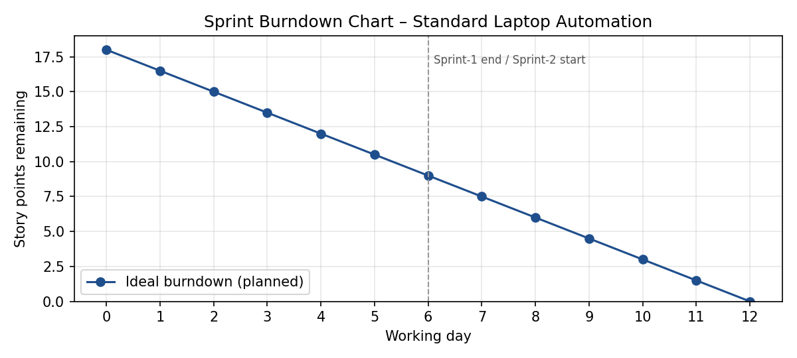
Reference:
https://www.visual-paradigm.com/scrum/scrum-burndown-chart/
https://www.atlassian.com/agile/tutorials/burndown-charts
https://www.atlassian.com/agile/project-management
https://www.atlassian.com/agile/tutorials/epics
https://www.atlassian.com/agile/tutorials/sprints
https://www.atlassian.com/agile/project-management/estimation

